Labeling the parts of the Microscope (Binder Section #4)

Name_____________________________________Date______________Class ____________

Objectives for you to be able to do by the end of the lesson:
-Know the parts of the microscope and be able to correctly identify them.
-Understand the functions of the microscope parts.
-Do : Apply your knowledge about microscope use to explain how a cell can appear differently under magnifications, using evidence from your resources.
PART 1: Identifying Microscope Parts…….
Go to the site: http://www.biologycorner.com/microquiz/index.html
Directions: Using the following words, label the parts of the Microscope

Ocular lens (eyepiece) arm stage clips
Low Power Objective (4x) High Power Objective (40x) nose piece
Body tube base stage
Diaphragm illuminator (light source) Scanning Power Objective(10x)
Course Adjustment Objective Fine Adjustment

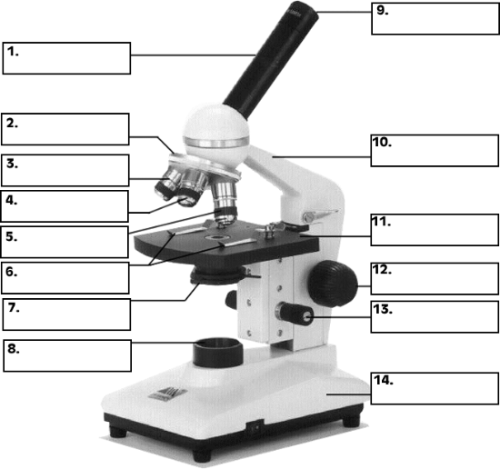

PART 2:
Further practice-

Go to this site:
https://www.wisc-online.com/learn/general-education/biology/bio905/how-to-use-a-microscope

Read and familiarize yourself with the microscope parts by dragging the cursor along.Go through the activity until you see this screen and complete the drag and drop quiz. Fill in the spaces below with the parts:

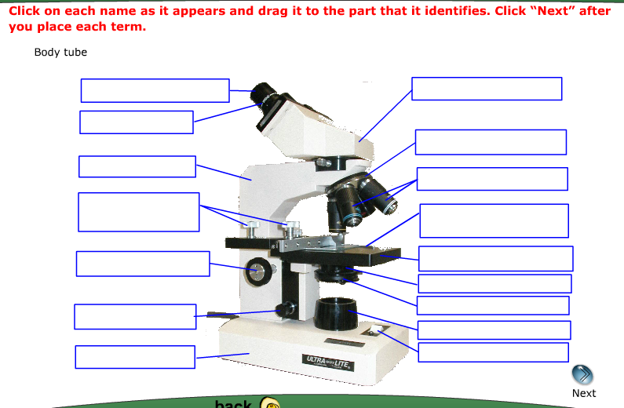

YOUR FEEDBACK:

1. Rate your performance on this activity, How did you do? : OR

2. How was the first activity different than the second activity?

3. Do you have any questions now? List anything you wonder about related to these two tasks.

Keep pressing “next”

Now continue through the activity until you get to the quiz at the end. Please fill in the blanks as you drag and drop the answers in the correct spaces:

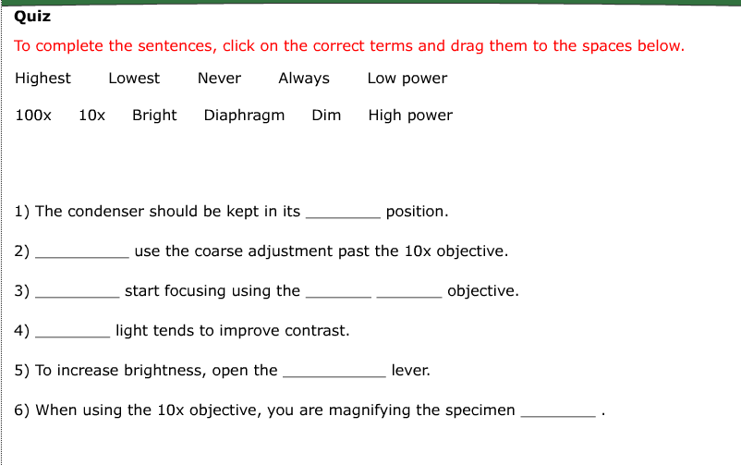

PART 3: How do you use the microscope’s parts to help you see cells?
Go to this site:

http://www.cas.miamioh.edu/mbi-ws/microscopes/Magnification.html

Go to this site and click on the tab that states “MAGNIFYING/FOCUSING”. Now you will learn how to focus the scope.

Please read through these steps of how to properly FOCUS an object and sequences them in the correct order .

Write the number on the line to the left of the step according to its correct order:
______________________________________________________________________________________

Step #__________ To magnify the image to the next level ON THE HIGHEST POWER, rotate the nosepiece to the 40X objective. While looking through the eyepiece focus the image into view using only the fine adjustment knob, this should only take a slight turn of the fine adjustment knob to complete this task. DO NOT USE THE COARSE ADJUSTMENT KNOB TO FOCUS ON HIGHEST POWER. This could easily damage your object you are looking at , the slide might crack, or the lens might be damages

Step #________ To magnify the image to the next level (medium power) rotate the nosepiece to the 10X objective. While looking through the eyepiece focus the image into view using only the fine adjustment knob, this should only take a slight turn of the fine adjustment knob to complete this task.

Step #_______ Beginning with the 4X objective, looking through the eyepiece making sure to keep both eyes open (if you have trouble cover one eye with your hand) slowly move the stage upward using the coarse adjustment knob until the image becomes clear. This is the only time in the process that you will need to use the coarse adjustment knob

Step #________ When viewing a slide through the microscope make sure that the stage is all the way down and the 4X lowest power objective is locked into place.

Step #_______ Place the slide that you want to view over the stage, and gently move the stage clips over top of the slide to hold it into place.
_______________________________________________________________________________________

Staying on this same page, please look at the instructions on how to calculate
TOTAL POWER of Magnification of what you are viewing. This means you combine the lens powers from the eyepiece with the objective lens power to get a sense of just how much magnification you are seeing the object with.

Please fill in this table below with the information about the total magnification powers of each lens you will be using:

Eyepiece Lens Power | Objective Lens Power | Total power of Magnification | What the Elodea Plant Cells look like---Press “CLICK HERE TO SEE THE IMAGE”
 |  |  | Drawing:
 |  |  | Drawing:
 |  |  | Drawing:

PART 3-FEEDBACK:

After clicking on the images of the Elodea cells at 400x total power, CLICK ON THE “side by side” comparison. Elodea cells are little cells that make up a plant that lives in water. You can buy them at aquarium stores.

- How were the images different in terms of sizes, details, shapes, etc?

- Explain a possible reason for why the images appeared different.

- Which of these statements is more accurate:
A. “The Elodea cells grow bigger when you see them under a stronger power objective lens”.

B. “The Elodea cells are magnified to look larger at a higher power lens than a lower power objectives lens.”

Explain a reason for your choice:

USE THIS SITE TO HELP YOU :
http://www.cas.miamioh.edu/mbi-ws/microscopes/Usage.html
Put the steps of how you use a microscope in order:
.

