Microscopic Measurement Practice
Directions: For this activity, you will require a computer, tablet or smart phone with internet access. If you do not have access to the internet through one of these resources, please see me privately in class and we will set up a time during the day to go to the computer lab.
STEP ONE: Go to the following website: http://virtualurchin.stanford.edu/microscope.htm
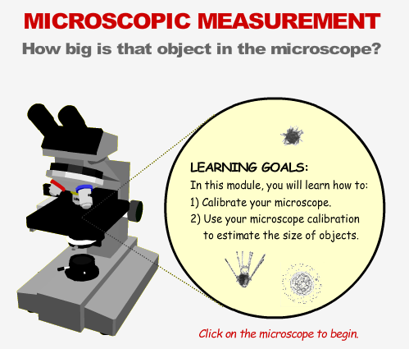
NOTE: You can also access this document and website on my weebly: www.mrsmotley.weebly.com
* click on “MOT’S THOUGHTS”-Look on the top link: there is a button to click on to get to the site as well.

When you arrive at the website, you should see this graphic on the screen.
Click on the microscope to begin the activity!

STEP TWO: Read each section as the tutorial guides you through each segment. In each reading, there is important information regarding what we are learning in class. On the bottom of each section, there are three buttons: CONCEPT - MICROSCOPE - HISTORY. Holding the cursor over each of these will give you more information too (you don’t have to click them).
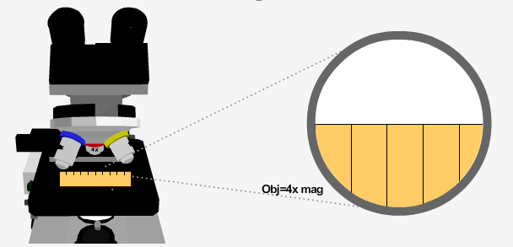
STEP THREE: To move on to the next section, you must click a part of the page – each section will be different. Sometimes the section will require you to click, hold, and move a part of the microscope – other times you must answer questions! Simply follow the step-by-step procedure and it will let you advance to the next section.
One section asks you to CALIBRATE THE MICROSCOPE. We will do this in class. To understand how big the object is in the microscope, we must USE A RULER to see how big the field of view is under each objective lens.
STEP FOUR:
When you reach the Calibrate Your Microscope Section, the activity asks you to drag a metric ruler on the stage of the microscope and record how much of the ruler you can see under each objective lens. Fill in the Measurement (mm or millimeter) portion of the chart chart below as you do on the computer.
Calibration Chart
Objective Lens | Measurement (mm) | Check
4x
10x
40x
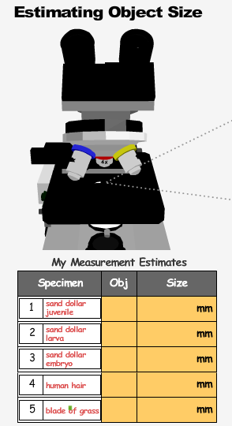
STEP FIVE:
When you reach Estimating Object Size, you will view 5
different objects under the most suitable objective lens.
Record (1) which objective lens is the most suitable for that
specimen, and (2) record what you think the size of that
specimen is (you must use the above calibration chart
for this!). My Measurement Estimates
Specimen | Objective Lens | Size
1) sand dollar juvenile |  | mm
2) sand dollar larva |  | mm
3) sand dollar embryo |  | mm
4) human hair |  | mm
5) blade of grass |  | mm
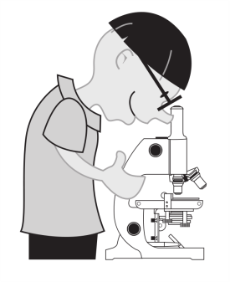
*Check your work on the next page when you finish!
******FINAL THOUGHTS:
Write 3 key points you learned from this activity
-2 things you liked about it.
-1 thing you have a question about or do not understand.******************
Microscopic Measurement Practice Homework.
Key points:
- THIS HOMEWORK IS DUE TO BE PUT IN YOUR SCIENCE JOURNAL- Staple it or glue it in after the date OCTOBER 2, 2013.
- -The purpose for this homework is to give you a preview and preparation activity for using microscopes.
- -After going through the online lab, you should feel more comfortable with the parts of the microscope and how they work.
- -I will be looking for a completed lab in your Journals when I collect them next.
- *Remember: you glue or staple the microscope lab page inside your journal.
- -If you do not have access to the internet or a computer, you must bring in a note signed by your parent and we will work computer availability out for you. You might also visit the library during homeroom or ask your enrichment teacher.

