SEED DISPERSAL STRATEGIES ACTIVITY DAY
Today you will learn about how seeds travel and why it is a benefit for them to be spread away from their “parent” plant they came from.
Just like seeds travel, or disperse, you will travel to different websites and various activities to help you learn the important concepts.
Use my weebly website(click on MOT’S THOUGHTS) as a guide to help you with each process task for the online activities.
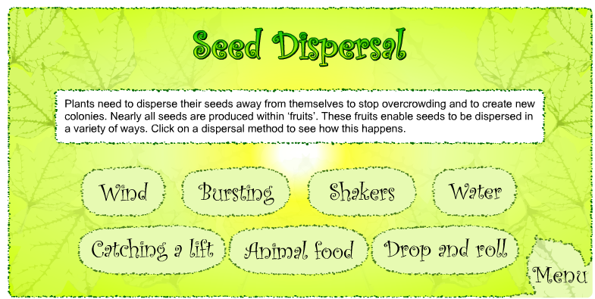
Task 1: The basics. Click on “The Basics” link on my Mot’s thought’s weebly site.
You should view a screen like this:
Read the main screen and explain why it
Is important for seeds to spread away from
the parent plant.
1._____________________________

2._____________________________
Click on each seed dispersal method. Fill in the table below:
Method of Dispersal | Structure of Seed that helps it get dispersed (its adaptation) | Example of a seed that disperses with that method
Wind | Seed has tufts on it that are light to float. | Dandelions or “helicopters” off of Maple Trees
How does the structure of each seed affect its function? Give an example:
__________________________________________________________________________________________

__________________________________________________________________________________________
Task 2: Click on “Quizzing Yourself!” A page like this will show up! Please go through the activity and fill in your responses.
Seed Dispersal Activity Sheet
Activity 1
Look at each of the pictures below and see if you can decide how the seeds are dispersed in each of these cases. What adaptations can you see to help the process of dispersal in each one? You can click on the answers to find out if you are correct or not or if you have printed out the sheet circle your answer. Print out the page and write in your answers for adaptations.
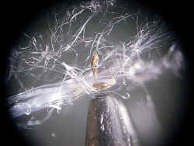 | 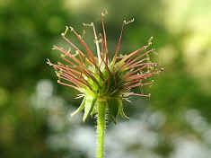 | 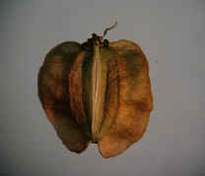
A (Note pencil tip for scale) | B | C (2mm long)
wind water animals explosive | wind water animals explosive | wind water animals explosive
Adaptations: | Adaptations: | Adaptations:
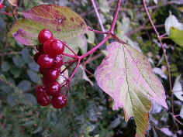 | 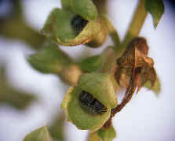 | 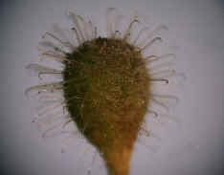
D | E | F
wind water animals explosive | wind water animals explosive | wind water animals explosive
Adaptations that the seed has: | Adaptations: | Adaptations:
TASK 3:
Flowering plants reproduce themselves by producing seeds. The seeds also provide the plants with a way to spread out and grow in new places, sometimes a long way from the parent. This is important because if the seeds are not dispersed, many germinating seedlings will grow very close to the parent plant. This results in competition between every one of the seedlings as well as with the parent plant. The competition is for light, space, water and nutrients. All of these are important for plants to be able to grow.

Seeds also get dispersed away from the parent plant to spread out the population. If a large population of plants all grew in one small space, and a natural disaster like a flood or a disease went through the population, the entire plant species would be extinct. If the plant spreads the population away from the main plant, there is a better chance for the plant species to continue its reproduction.
Seeds can be dispersed in a number of different ways. They may be carried by wind, water or animals. Some plants even shoot the seeds out explosively. Seed size is an important factor.

The seeds of flowering plants vary in size. Some are as small as grains of salt (e.g Foxglove), while others may be almost the size of golfballs (e.g. Horse Chestnut conkers). The difference in size reflects differences in the amount of food reserves stored in the seed for the benefit of the embryo plant inside. Usually, the larger the seed, the more food reserves it contains. This allows the germinating seed and young seedling more time to grow. It can then become well established before it must begin manufacturing its own food. The longer a seedling has before it must become self sufficient, the greater chance it has of becoming successfully established.
However, there is a down-side to having large seeds. The larger and heavier the seed, the more difficult it becomes to disperse it effectively by wind, or explosive techniques. All of these require light seeds. Seeds such as Foxglove are minute and are easily blown about by the wind. Larger wind-dispersed seeds are generally heavier and therefore require features such as parachutes or wings to help keep them aloft. For example, Dandelion seeds have developed very light and fluffy parachute-like structures. These help the seeds to float in the wind and delays their fall to the ground. This delay allows the seeds to be carried further. The largest and heaviest wind-dispersed seeds, such as Sycamore cannot rely on hair-like parachutes to keep them airborne. They would have to be enormous to be effective. Instead they have developed a wing which causes them to spin through the air like mini helicopters. This again delays their fall.
The biggest seeds of all cannot possibly be dispersed by the wind. Large seeds such as nuts, are a valuable food for some animals. They are therefore often dispersed by animals which collect them to eat. Rarely are all such seeds eaten. Some will usually be overlooked, leaving them to germinate wherever they have been left when conditions are right.
Answer the questions:
- According to this text, the two main reasons seeds get dispersed away from the parent plant are:
- Seeds spread away from the parent plant to have more freedom.
- Seeds are dispersed from the parent plant to prevent competition for resources like food, water, sunlight, etc.
- Seeds spread away from the parent plant to decrease the risk of the species being wiped out from a disease or natural disaster.
- Seeds get dispersed from the parent plant to float away on parachute-like structures.

- Highlight, or underline the text that provides evidence for your response to #1.

- Why did the author discuss the advantages and disadvantages of the structures of the seeds? Cite evidence from the text to support your response.

Task 4: Research about an interesting seed of your choice. Post the name of the seed and a picture of it on my website. Then explain why your seed is so interesting in your opinion. (click on leave a comment)

Task 5: Extra Credit Homework- Choose 1 of the following options below:
Design your own seed that flies as far as possible. Use the template your teacher gives you as a model. | Go to the 3rd site :”TESTING YOUR SEED”.  -develop the most optimal seed design that flies the farthest from the main plant.  -Write a description of your seed from what you learned after doing the activity.  -include the quantitative data  (size, mass, wind speed, distance travelled etc) you tested with for your seed. | Go on a seed hunt: Go home and collect 5 different seeds you can find outside or INSIDE!  -Put each seed in a separate bag and label the method of seed dispersal on the label.  -Write a brief statement of how the seed’s structure helps it get spread in that way.
Due FRIDAY | DUE FRIDAY | DUE FRIDAY

